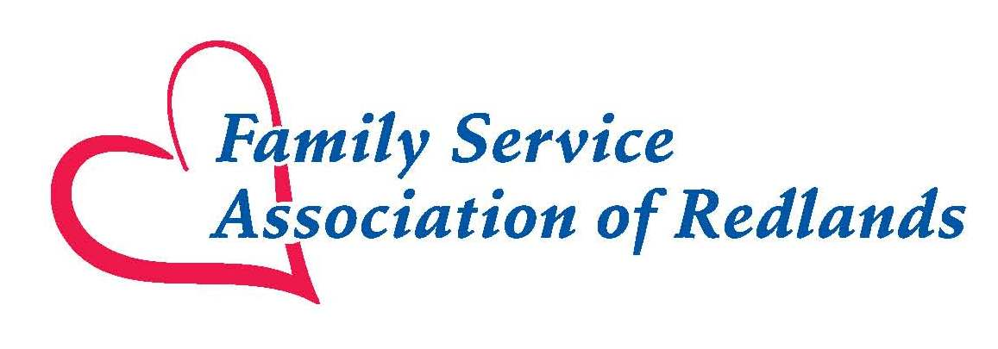
Monthly Food Box Needs

- Veggie Cans
- Soup Cans
- Bag/ Boxed Pasta
- Peanut Butter
- Jelly
- Dry/ Canned Beans
- Canned Chicken Broth
- Boxed Stuffing
- Top Ramen
- Rice
- Rice-a-Roni
- Hamburger Helper
- Canned Tuna
- Canned Chili
- Oatmeal
- Cereal
- Cake Mix
- Jell-O
- Instant Mashed Potatoes
- Cooking Oil
- Pancake Mix
- Tomato Sauce
- Tea/Coffee

